April 2nd, 2025

19362 Hartsford Ln

Carhage, MO 64836

Dear Homeowner,

We were just contacting you about your water equipment, but we do not have the correct contact information.

If you could call me at (316) 265-6111 so that I can update the full file with your information and go over any product and maintenance information you need. Any information would be very helpful. You can call or email me at [service.schedule@moorewatertreatment.com](mailto:cheyenne.martin@moorewatertreatment.com) if that is easier.

Sincerely,

Teona Davis

Moore Water & Air

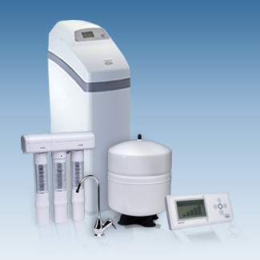 Check us out at [www.ecowaterofkansas.com](http://www.ecowaterofkansas.com/)